**SANYO MBC-1000**

The MBC-1000 was the bottom-of-the-range system of a series of "Creative Computer" CP/M machines which was also comprised of the 11xx and 12xx ranges.

Although its design wasn't revolutionary, it was a well-built and reliable machine featuring a detachable keyboard, a 12-inch green monochrome screen and a single built-in 5.25, 327 KB floppy drive.

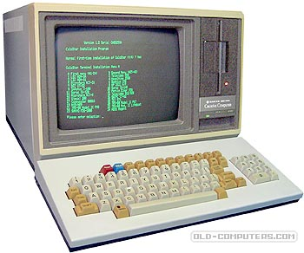

It ran CP/M 2.2 OS with a very fast boot up sequence. The OS was ready to run in less than five seconds after the machine was switched on. The whole family of Micropro software - WordStar, CalcStar, DataStar, ReportStar... was specially modified to fit MBC-1000 features. Sbasic, an extended Basic interpreter, was included into the CP/M master diskette.

Sanyo CP/M machines had a discreet life in business world and were gradually replaced by PC compatible systems.

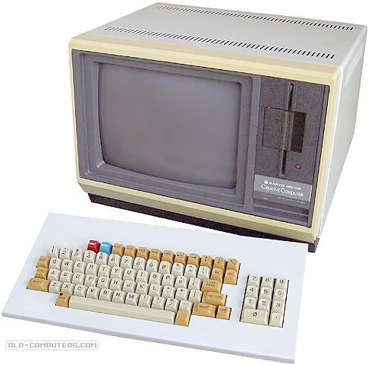

Extracts from the marketing brochure:

- Compact design integrating all the functions for multi-purpose applications

- Z-80A CPU ensures high-speed processing with no-wait mode

- A substantial library of business software has been developed in the United States to Sanyo's specifications. Sanyo will also offer word-processing, electronic spread-sheets, and related software to its distributor and dealer network. A user encyclopedia for the extensive, powerful SBASIC II is supplied with the machine. The Sanyo computer will support all CP/M compatible software and along with the appropriate interpreter or compiler, programs can be run in C-Basic, M-Basic, Fortran, Cobol, Forth and others. Sanyo will support and publish a list of approved software products to its dealers, distributors and end users.

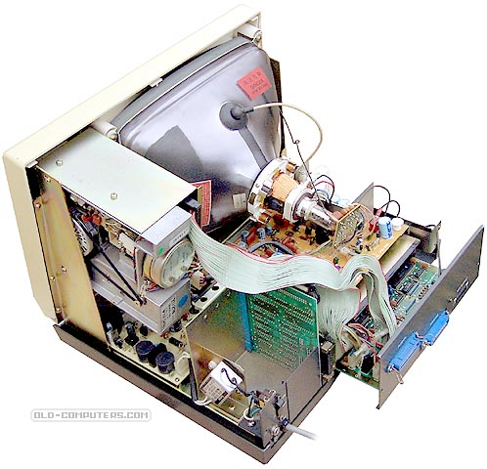

- SBASIC II adds several additional commands and statements to those featured by Microsoft BASIC. The disket supplied includes a set of Check programs and Utilities allowing extra programming flexibility.

- Built-in floppy disk drive with file copy procedure can be expanded to incorporate up to three 5"1/4 or two 8" additional floppy disk drives. The expandability to over 2.3 MB of disk storage assures the capacity to meet your needs.

- Easy-to-operate typewriter-style keyboard with numeric pad and five function keys for easy program execution

- 12" non-glare green phosphor video display screen showing up to 256 standard and graphic characters. For special graphic or alpha-numeric needs, programmable character generator allows you to change any character to meet these requirements.

- Centronics parallel printer port, RS-232C serial port, and additional 5"1/4 floppy expansion disk port are standard.

- Additional interface cards are available for a parallel port or RS-232 port.

- The interface card for the EFD860F (additional 8" external drives) is packaged with the EFD860F

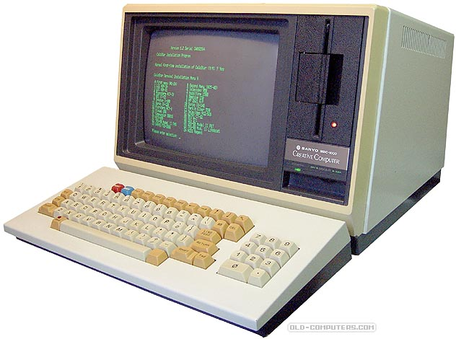

|  |  |
| --- | --- |
|  |  |

|  |  |
| --- | --- |
| **NAME** | MBC-1000 |
| **MANUFACTURER** | Sanyo |
| **TYPE** | Professional Computer |
| **ORIGIN** | Japan |
| **YEAR** | 1982 |
| **BUILT IN LANGUAGE** | SBASIC II (Microsoft Basic with additional commands specific to the system) |
| **KEYBOARD** | Typewriter type, 83 keys with numeric keypad, 5 function keys & arrow keys |
| **CPU** | Z80A |
| **SPEED** | 4 MHz |
| **RAM** | 64 KB |
| **VRAM** | 2 KB (video) + 2 KB (character generator) |
| **ROM** | 2 KB |
| **TEXT MODES** | 80 columns x 25 lines (8x8 dots character matrix. Programmable character generator) |
| **GRAPHIC MODES** | None |
| **COLORS** | Monochrome green phosphore (12'' non-glare monitor) |
| **SOUND** | built-in Buzzer |
| **SIZE / WEIGHT** | Main unit: 40.5 (W) x 31.7 (H) x 35.7 (D) cm / 14 kg Keyboard: 41 (W) x 7.6 (H) x 21.1 (D) cm / 3.5 Kg |
| **I/O PORTS** | Parallel printer, external FDD unit, Serial RS232 (1200-8500 BPS baud rate) |
| **BUILT IN MEDIA** | Built-in 5.25'' 327 KB floppy-disk drive |
| **OS** | CP/M 2.2 |
| **POWER SUPPLY** | Built-in, switching power supply unit (45 W) |
| **PERIPHERALS** | Up to 5 expansion cards, up to three 5''1/4 or two 8'' drives can be added |
| **PRICE** | $1500 (fall 1982, USA) $3,995 (1983, USA) - includes a second 5 1/4 inch drive, a daisy wheel printer, the software package and 8 hours of instructions in WordStar, CalcStar and installation |

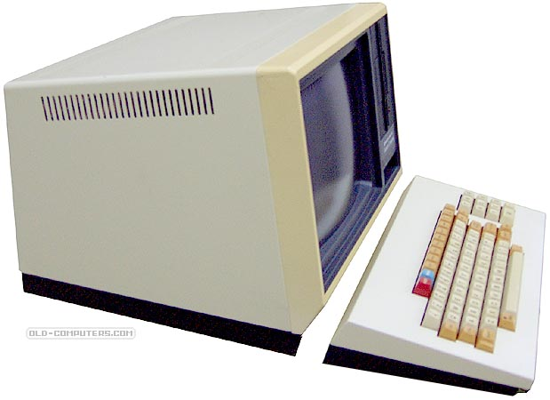

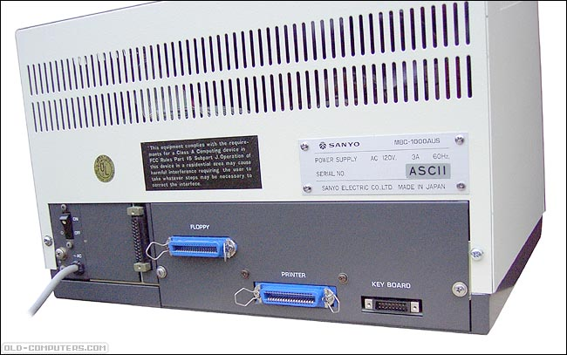

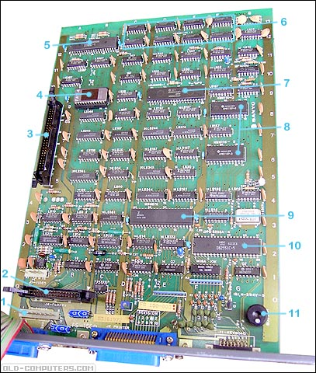

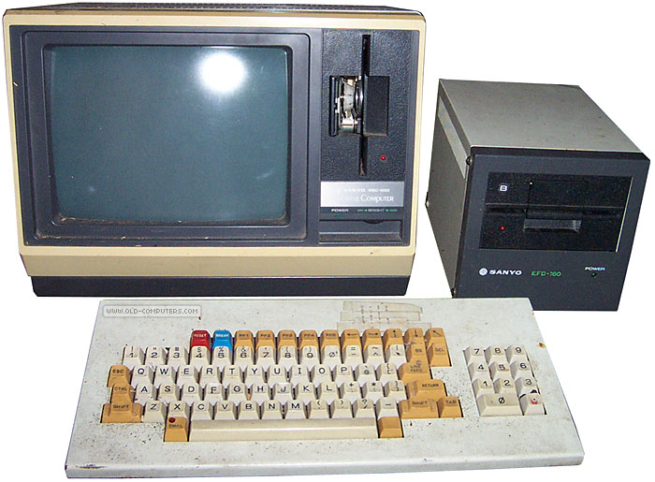

参考文献

http://www.old-computers.com/museum/computer.asp?st=1&c=1072